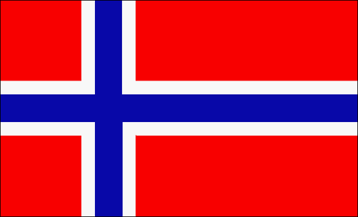
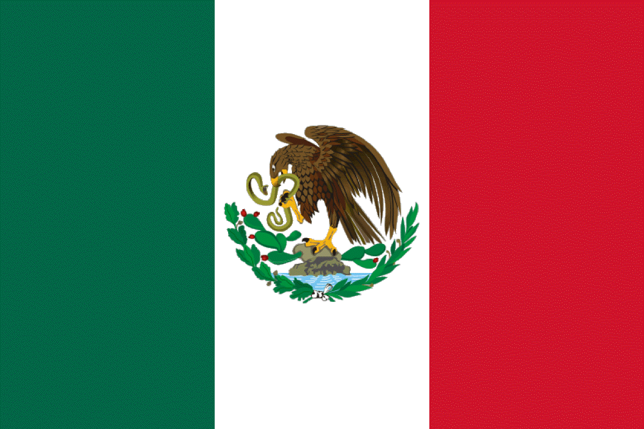
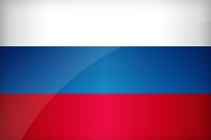
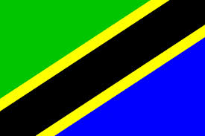
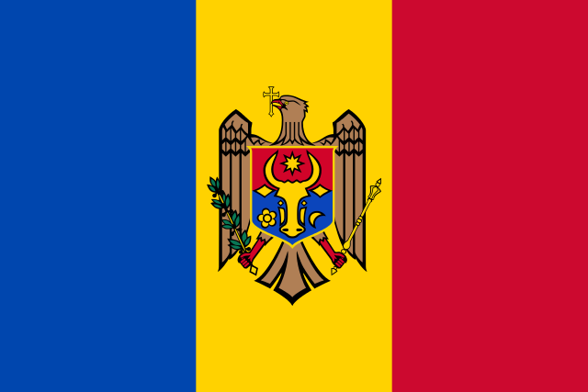

CHINOOK
Thursday, March 28
6 - 8PM Chinook Commons
All Heritage
Community Festival
Potluck Dinner
Food * Crafts * Dance * Art * Games
Share your family’s culture!

USA Southwest | Ethiopian | Vietnamese | Malaysian | Nigerian
Turkish | Spanish | Finish | Thai | South Asia
Korean | Japanese | USA East Coast | Swiss | Ukrainian
Russian | Middle Eastern | Mexican | Chilean | Guatemalan
USA Midwest | Australian | Armenian | Latin American | Canadian
Chinese | Brazilian | Samoan | Austrian | Egyptian
Italian | USA Northwest | French | Honduran | Iranian
Native American | Polish | Hungarian | Moldavian | Bulgarian
English | German | Central Asia | Pakistani | Irish

*Bring your favorite entrée, side dish or dessert to share!
*Volunteers needed for performances and stations.
Contact: moej@bsd405.org OR 425-456-6305
